*) mp.plot(testY, 'r')

mp.plot(test_predict, 'b')

*) mp.plot(train_error_summary, 'gold')

mp.plot(test_error_summary, 'b')

test_predict [0.79618764]

Tomorrow's Daily Mean Air Temperature [74.373474]

1. BS

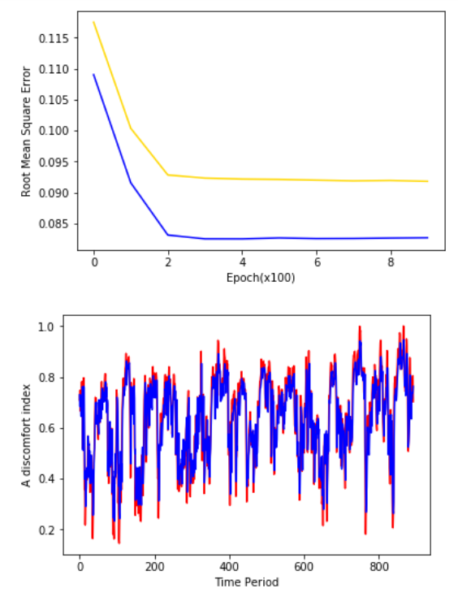

test_predict [0.6606614]

Tomorrow's Daily Mean Air Temperature [76.07031]

1. CC

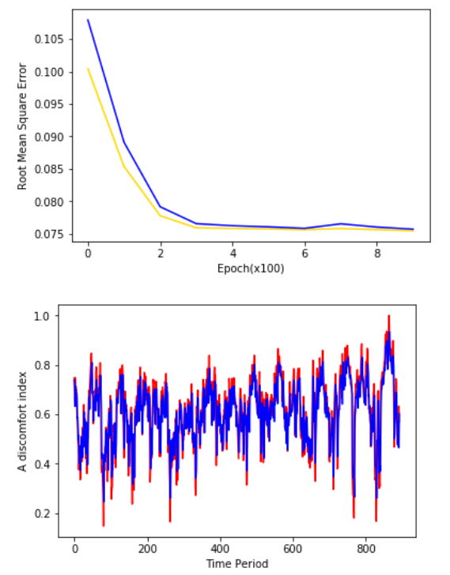

test_predict [0.5433411]

Tomorrow's Daily Mean Air Temperature [73.090996]

1. CJ

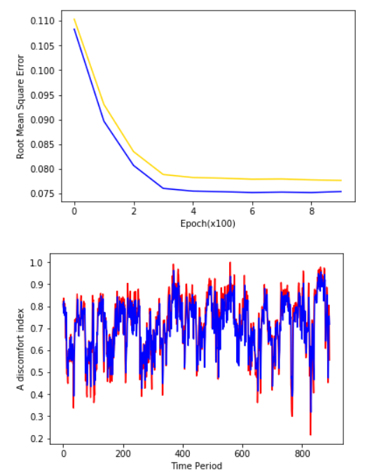

test_predict [0.5317478]

Tomorrow's Daily Mean Air Temperature [71.413315]

1. CPR

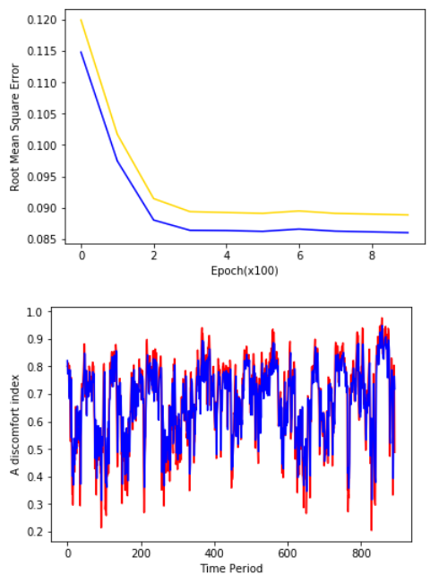

test_predict [0.4910323]

Tomorrow's Daily Mean Air Temperature [69.006195]

1. DG

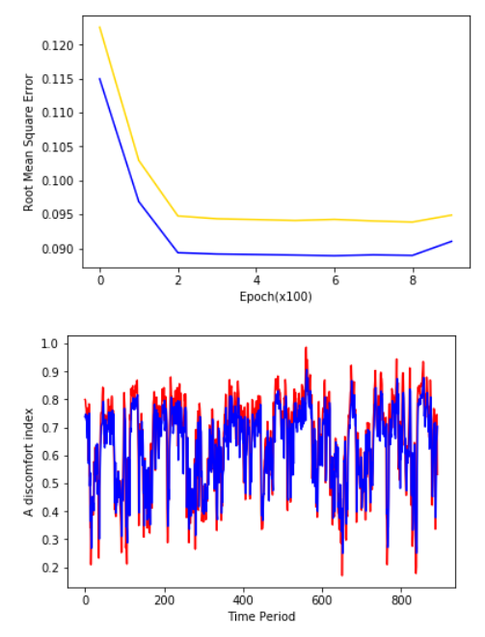

test_predict [0.49675575]

Tomorrow's Daily Mean Air Temperature [72.84846]

1. DJ

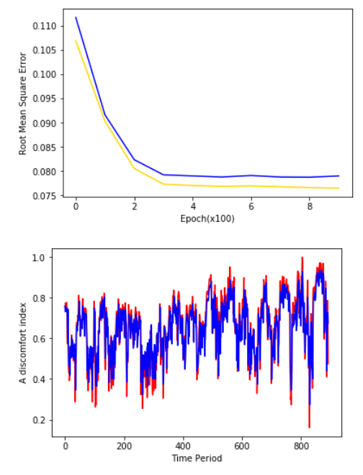

test_predict [0.45716986]

Tomorrow's Daily Mean Air Temperature [71.029106]

1. GJ

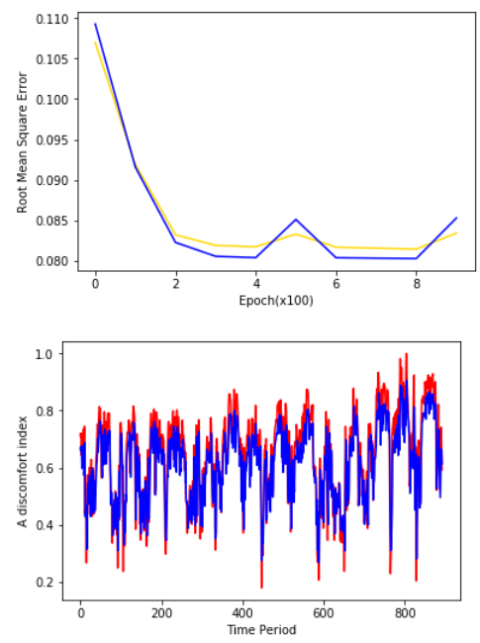

test_predict [0.5369329]

Tomorrow's Daily Mean Air Temperature [74.68599]

1. IC

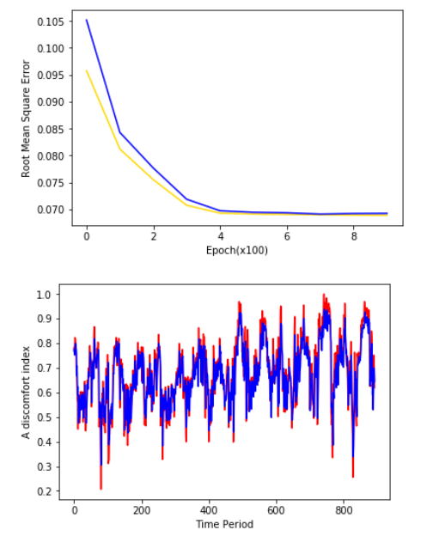

test_predict [0.59873366]

Tomorrow's Daily Mean Air Temperature [73.144135]

1. JJ

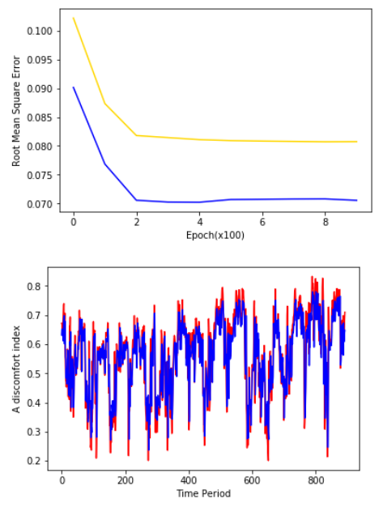

test_predict [0.66897166]

Tomorrow's Daily Mean Air Temperature [79.93579]

1. MF

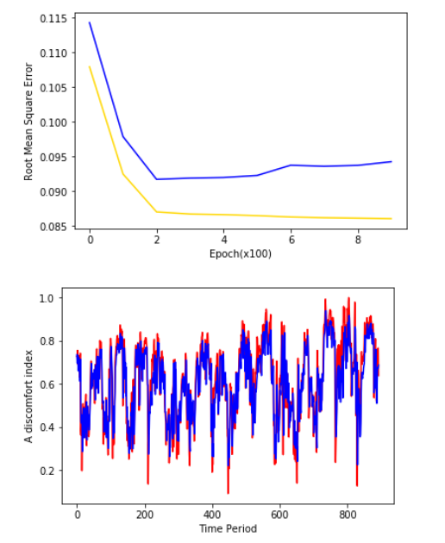

test_predict [0.55009705]

Tomorrow's Daily Mean Air Temperature [75.67963]

1. SC

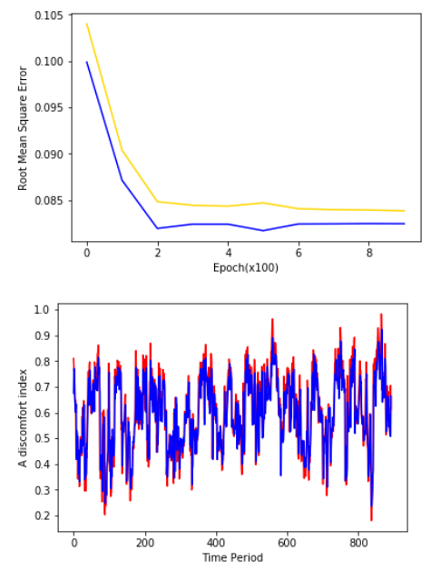

test_predict [0.56731844]

Tomorrow's Daily Mean Air Temperature [72.47516]

1. SU

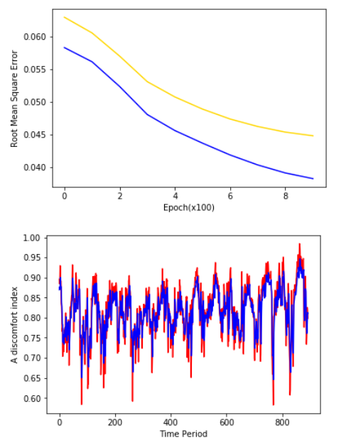

test_predict [0.79798025]

Tomorrow's Daily Mean Air Temperature [74.4656]

1. TY

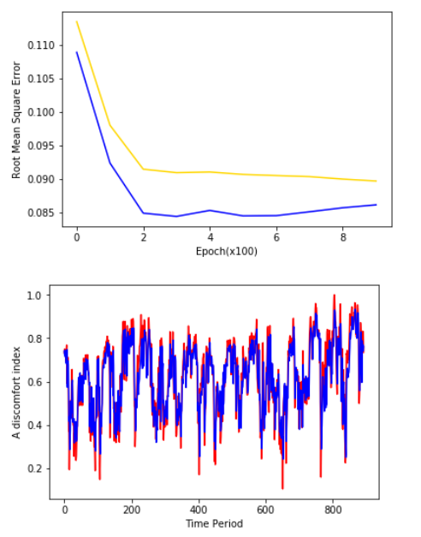

test_predict [0.6636106]

Tomorrow's Daily Mean Air Temperature [76.602806]

1. UR

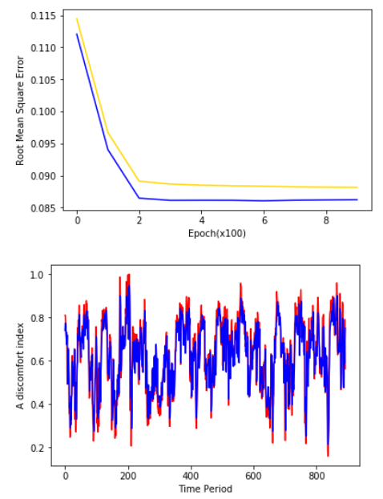

test_predict [0.53052294]

Tomorrow's Daily Mean Air Temperature [70.2362]

1. US

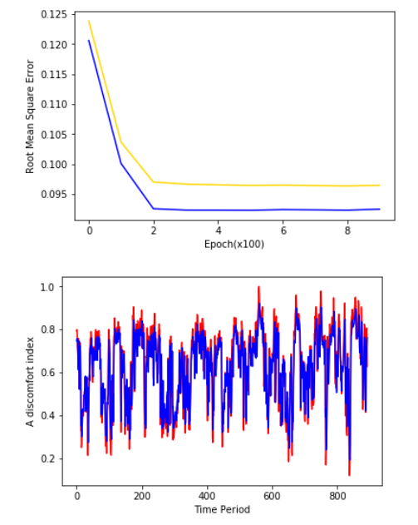

test_predict [0.58295524]

Tomorrow's Daily Mean Air Temperature [74.908646]

1. YS

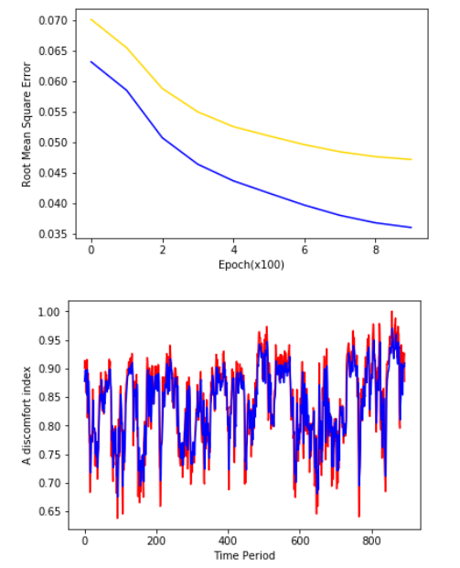

test_predict [0.8717675]

Tomorrow's Daily Mean Air Temperature [77.30519]